Suggested Car Route

Entering Portsmouth from the North, RI Rte 24, take Exit 1. Make a right and follow Hummocks Ave under Rte 24. At about two miles (just past 15 Point Rd Restaurant) is the Old Stone Bridge.

1. Old Stone Bridge. Site of bridges to Tiverton dating back to the 1795. This was one of the earliest ferry sites as well. The last Stone Bridge was badly damaged in Hurricane Carol in 1954 and was replaced by the Sakonnet River Bridge.

Continue on Park Avenue for about one mile. Take a right onto Boyd's Lane. After about 3/4 mile look for the Founders' Brook Park sign. Take a left and park in the parking lot on the left. Walk up to the park via the path just beyond the parking area.

2. Founder's Brook Park. After their departure from Massachusetts in 1638, Anne Hutchinson, John Clark and William Coddington led a group of religious dissenters to the northern part of Aquidneck Island. The Portsmouth Compact, inscribed on a plaque at the landing site off Boyd’s Lane, established a democratic form of government.

Continue west on Boyd's Lane and just before the on ramp to the Mt. Hope Bridge make a Right onto Bristol Ferry Rd. The Bristol Ferry Town Commons is about 1/2 mile down.

3. Bristol Ferry Town Common. Site of town common dating back to 1714. Ferry service started here in 1640. This area became a transportation hub for Portsmouth with steamboats, trolley’s, trains and ferries all stopping here. The opening of the Mount Hope Bridge in 1929 ended the ferry service.

Drive back on Bristol Ferry Rd. Make a right just before and go under the Mt. Hope Bridge and make a right at the traffic signal to continue on Bristol Ferry Rd. At the next traffic signal, make a left onto Sprague St. In about a half mile turn right onto Dyer Street. Continue up the hill to Ft. Butts

4. Ft. Butts. In 1776 the Americans built a small battery on Butt’s Hill (also called Windmill Hill). The British and Hessians occupied the fort in December of 1776 and enlarged it to hold barracks for 200 men. During the Battle of Rhode Island in August of 1778, the fort was an American strong hold and the whole battlefield could be seen from this position.

Continue East on Sprague St and make a right onto East Main Road. Past the next traffic signal on your left is Lafayette House.

5. Lafayette House
2951 East Main Road
Also known as the Joseph Dennis house (1760), French General Lafayette stayed here just before the Battle of Rhode Island.

Continue about one and a half miles (through the traffic signal and just past the Police and Fire Stations) bear right onto Middle Rd. The Friends Meeting House is on the right at the stop sign.

6. Friends Meeting House. The Portsmouth Society of Friends was founded in 1658 and this Meeting
House was completed in 1700. It is now known as the Portsmouth Evangelical Friends Church.

Make a right at the stop sign onto Hedly St. Follow the road and make a right onto West Main Rd. Bear left onto Rte 114 and Patriots' Park is on your left.

7. Patriots Park
West Main Road at split of Rte 114 with Route 24. Memorial to the 1st Rhode Island Regiment, known as the "Black Regiment". Flagpole commemorates the site where the Black Regiment courageously fought off a Hessian attack, saving the American line.

Take a left out of the park and make a u-turn just after the overpass to proceed back south on West Main Rd. Continue three and ahalf miles to the Portsmouth- Middletown town line and park on the left at Prescott Farm

8. Prescott Farm (Overing House)
West Main Road at town line.
Site of the British General Richard Prescott’s nighttime capture in July 1777, by colonial militia led by Colonel William Barton. The site is owned by the Newport Restoration Foundation (small admission charge) and besides the Overing House (1730) it includes relocated Portsmouth colonial homes: The Hicks House (1715). from Bristol Ferry Road and the Sweet Anthony House (1730) from West Main Road. And The Sherman grist mill (1812) that had been located on Lehigh Hill.

Take a right out of the Prescott Farm parking lot and head north on West Main Rd. Make right at the traffic signal onto Union Street. 1/2 mile down on Union St will be the Julia Ward Howe Oak Glen House

9 Oak Glen
745 Union Street.
Oak Glen was the home of Julia Ward Howe, the author of words of "The Battle Hymn of the Republic." She died here on October 17, 1910, at the age of 91.

Continue east on Union St to the corner of East Main Rd to the Portsmouth Historical Society.

10. Historical Society Museum
Corner of East Main Road and Union Street.
This was the former Christian Union Church where Julia Ward Howe and other notables preached. It now houses a museum (open on Sundays 2-4 PM from Memorial Day to Columbus Day). The state’s oldest schoolhouse, Southermost School (1720’s) is on the grounds as well as Portsmouth’s Old Town Hall which contains farm equipment, wagons and a horse drawn hearse.

For the following sites, take right on East Main Road and take the next left onto Linden Ln. 1/4 mile on the right is the Edward Brown House. Continue down Linden Ln. and make a left at the end of the field. The Phelps House is on your right. Continue down the road past the Glen Farm Stables. Continue past the stables and make a left on Glen Farm Road. Make a right onto Glen Rd and a right onto Frank Coelho Dr. and proceed down to the Glen Manor House

11, 12, 13 The Glen:
Linden Ln and Glen Road off East Main Road.
There are several historical sites in the town-owned Glen Farm area. The (13) Glen Manor House (1923) was designed by John Russell Pope as the summer home for the Taylor Family. (11) The Leonard Brown House (c. 1850) is in the process of being restored. It was the home of a very prominent Portsmouth farmer and served as a support house for Glen Farm. (12) The Glen Barns were built from 1907 - 1910. across from the barns is the colonial Cundall Slocum graveyard.

Proceed back up to Glen Rd. Continue west on Glen Rd. Take a left onto East Main Road. At the second traffic signal take a left onto Sandy Point Rd. In ½ mile, take a right onto Wapping Road. Greenvale Vineyards is about 3/4 mile on the left

14. Greenvale
582 Wapping Road
Originally Greenvale Farm, it was built on the idea of a “Gentleman’s Farm”. Owner John Barstow’s intent was to find a 50 to 60 acre farm to “establish a rural agricultural retreat but one that would provide occupation as well as recreation.” Today the same family has a vineyard and continues to farm the land. Of special interest is the restored stable that has become a tasting room.

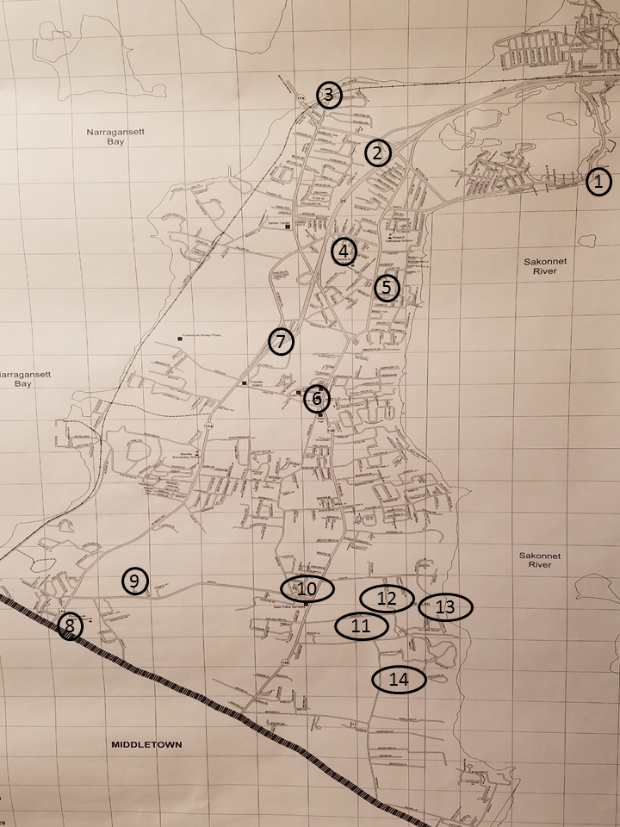

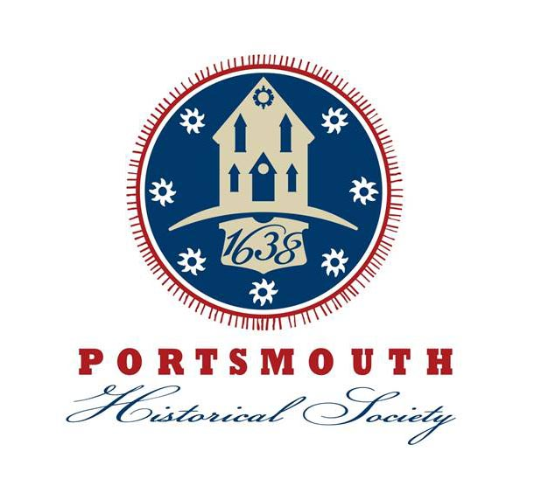

A Tour of
Historical Sites
in Portsmouth,
Rhode Island

